COMP 3610: Big Data Analytics
Assignment 4 — MLOps & Model Deployment
Evidence Report
Service: taxi-tip-api · Model: taxi-tip-regressor (Random Forest)
1. Evidence Summary
This report maps each Assignment 4 deliverable to the screenshot evidence captured from the working service. Items marked
Task 2.1 — Model loading + /predict
The right panel of Fig. 1 shows the full uvicorn startup: the model is loaded exactly once before the server accepts requests. The /predict response in Fig. 2 returns all three required fields — prediction_id (UUID), tip_amount (2 dp), and model_version. Six parametrised validation tests in Fig. 1 (test_predict_rejects_invalid_input) exercise distinct Pydantic constraints — hour above 23, hour below 0, negative fare, zero fare, wrong type for passenger_count, day out of range — each returning HTTP 422.
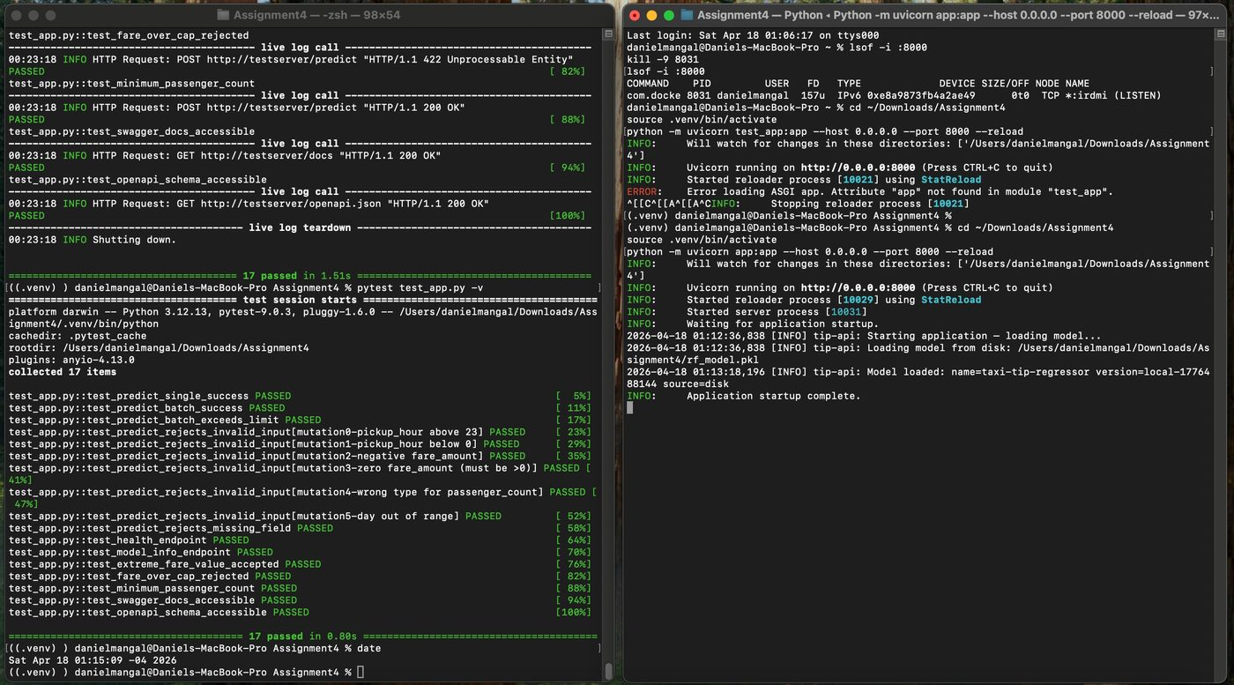
Figure 1 — Left: 17/17 pytest tests pass in 0.80s, including six parametrised invalid-input cases. Right: uvicorn startup log shows “Model loaded: name=taxi-tip-regressor version=local-1776488144 source=disk” before the server begins accepting traffic.
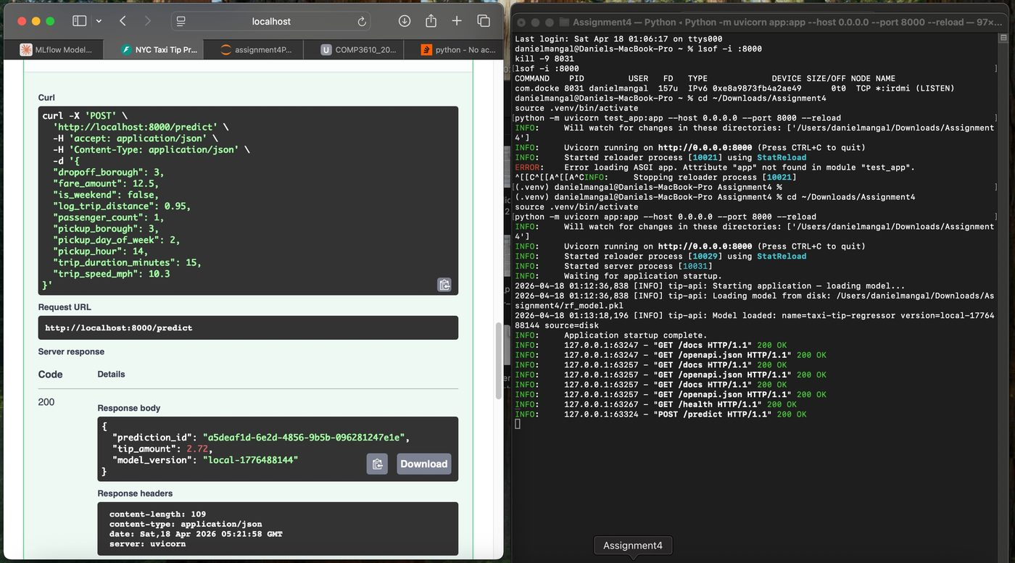
Figure 2 — Swagger POST /predict returns prediction_id (a5deaf1d…), tip_amount=2.72, and model_version=local-1776488144.
Task 2.2 — /health, /predict/batch, /model/info
The /health endpoint (Fig. 3) returns status, model_loaded and model_version as required. The /predict/batch endpoint (Fig. 4) returns batch_id, count, and a predictions array — and the batch-size cap is exercised by test_predict_batch_exceeds_limit (Fig. 1). The /model/info endpoint is covered by test_model_info_endpoint, which passes in Fig. 1. Invalid inputs return structured 422 responses rather than stack traces, confirming the global exception handler is active.
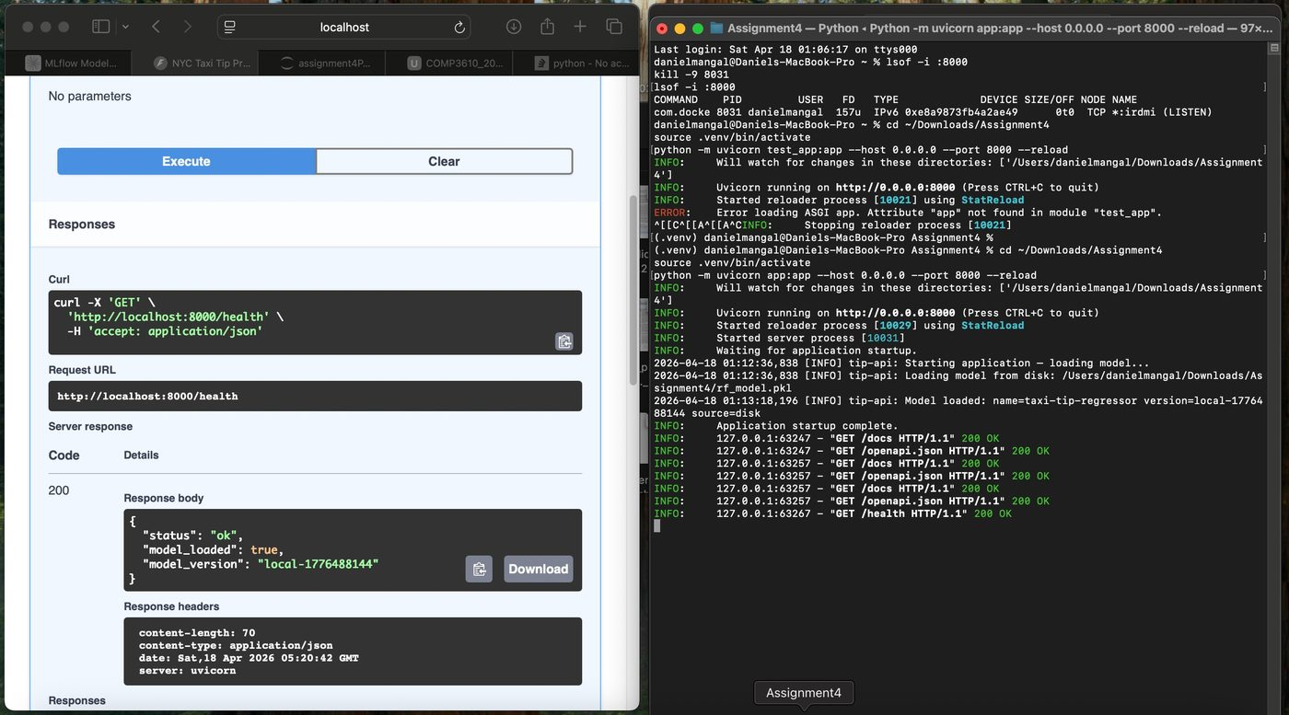
Figure 3 — GET /health returns {status: ok, model_loaded: true, model_version: local-1776488144}.
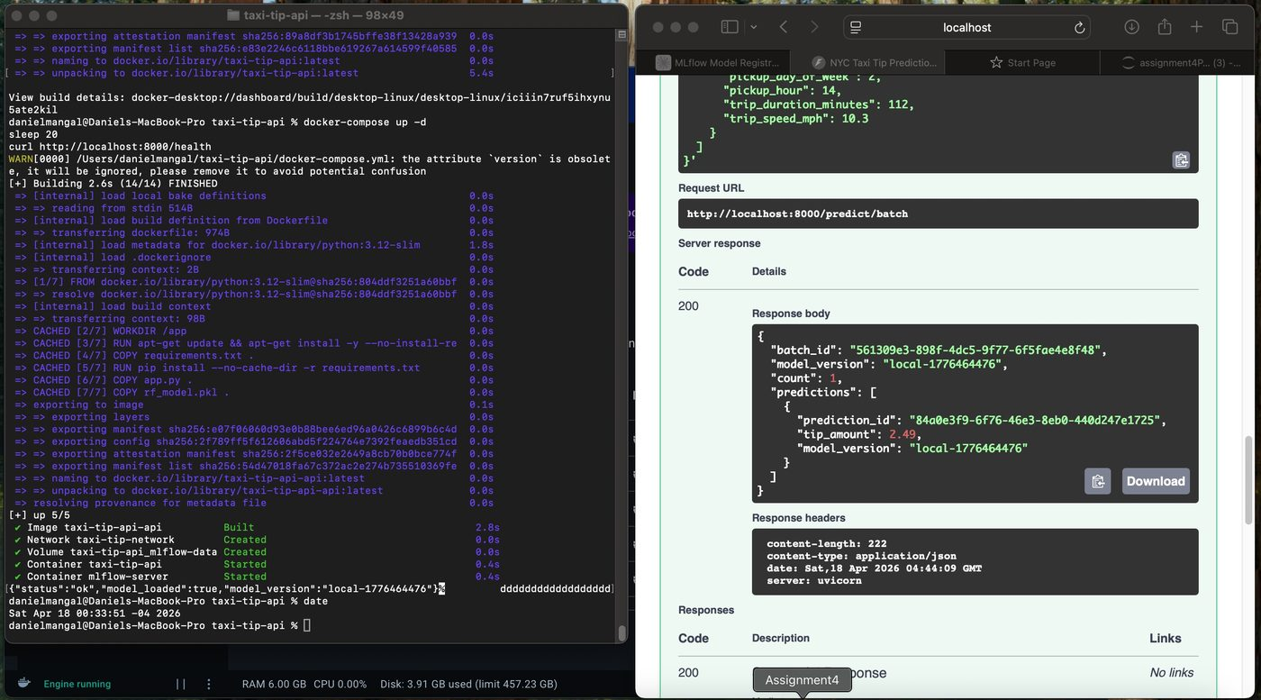
Figure 4 — POST /predict/batch returns batch_id (561309e3…), count=1, and a predictions array with tip_amount=2.49.
Task 2.3 — Tests & Swagger UI
The pytest suite collects 17 tests and all pass in 1.51s — covering single prediction, batch prediction, batch-size enforcement, six invalid-input variants, missing-field rejection, health, model-info, extreme-fare acceptance, over-cap rejection, minimum passenger count, and Swagger /docs + /openapi.json accessibility. Swagger UI is demonstrated in Figs. 2, 3 and 4, all captured from http://localhost:8000/docs.

Docker Containerization
4.1 docker compose up — bonus MLflow service
docker compose up -d completes with [+] up 5/5 (Fig. 5): the taxi-tip-api image builds in 2.8s (cached), the taxi-tip-network and mlflow-data volume are created, and both the taxi-tip-api and mlflow-server containers start. The curl http://localhost:8000/health output at the bottom left returns {status: ok, model_loaded: true, model_version: local-1776464476}, confirming the containerised API is reachable. The right panel shows pytest re-running against the containerised API with 17/17 passing. The second mlflow-server service satisfies the +5 bonus.
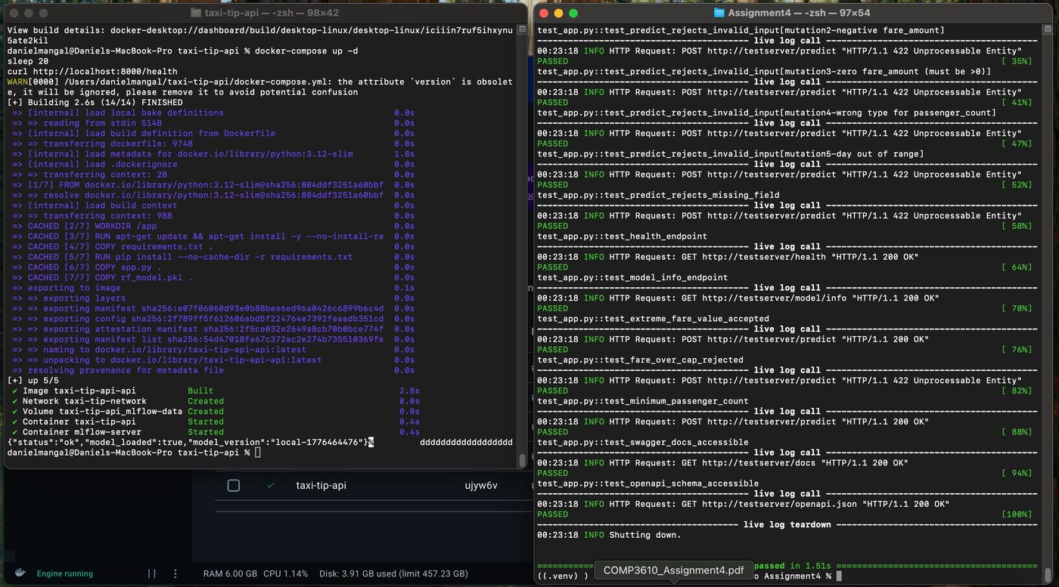
Figure 5 — docker compose up -d (left) starts both services (taxi-tip-api, mlflow-server) on taxi-tip-network; pytest re-run against the containerised API passes 17/17.
4.2 External predictions against the container
Three distinct predictions were made from Safari on the host against the containerised API on localhost:8000/predict. Each response carries a unique prediction_id and the same model_version (local-1776464476), demonstrating reproducible predictions with per-request traceability. Features are varied across predictions (weekday vs weekend, low vs high fare).
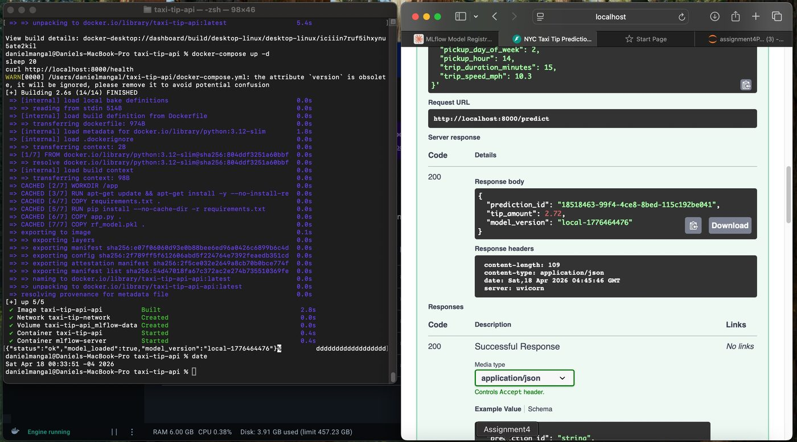
Figure 6 — Prediction #1: weekday trip, fare_amount=12.5, passenger_count=1, pickup_hour=14 → tip_amount=2.72 (model_version=local-1776464476).
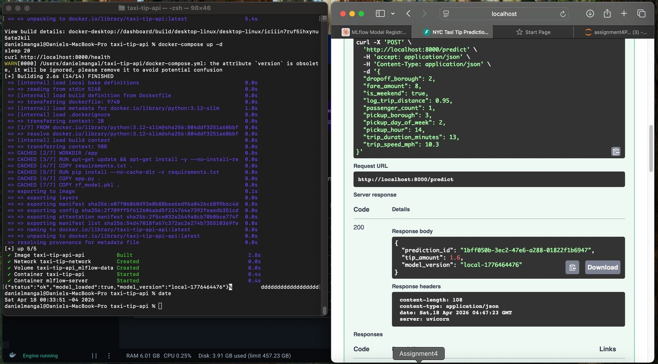
Figure 7 — Prediction #2: weekend trip, lower fare_amount=8, trip_duration_minutes=13 → tip_amount=1.60 (lower prediction for lower fare, as expected).
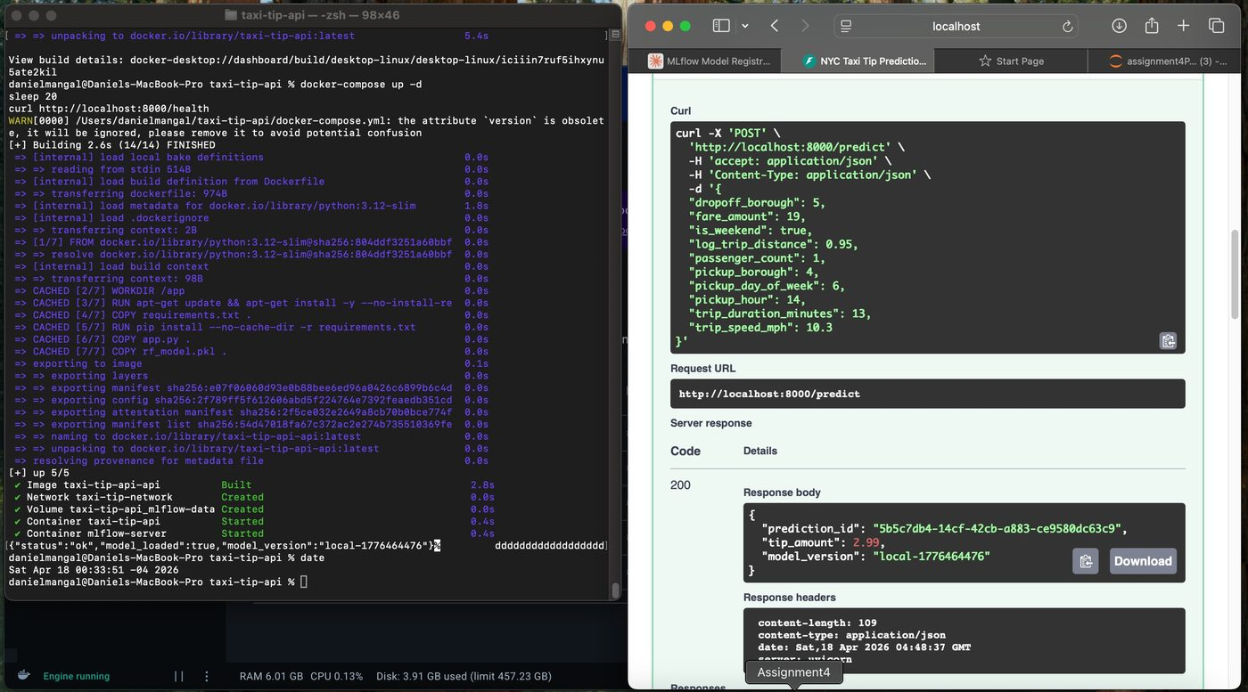
Figure 8 — Prediction #3: weekend trip, higher fare_amount=19, pickup_day_of_week=6 → tip_amount=2.99.
4.3 Image build
docker build -t taxi-tip-api:latest . completes in 70.5s across all 12 layers (Fig. 9). The build uses python:3.12-slim as the base, installs gcc via apt (16.8s), installs Python dependencies from requirements.txt (24.6s), and copies app.py and rf_model.pkl into /app. Run docker images taxi-tip-api:latest to get the final image size for the README.
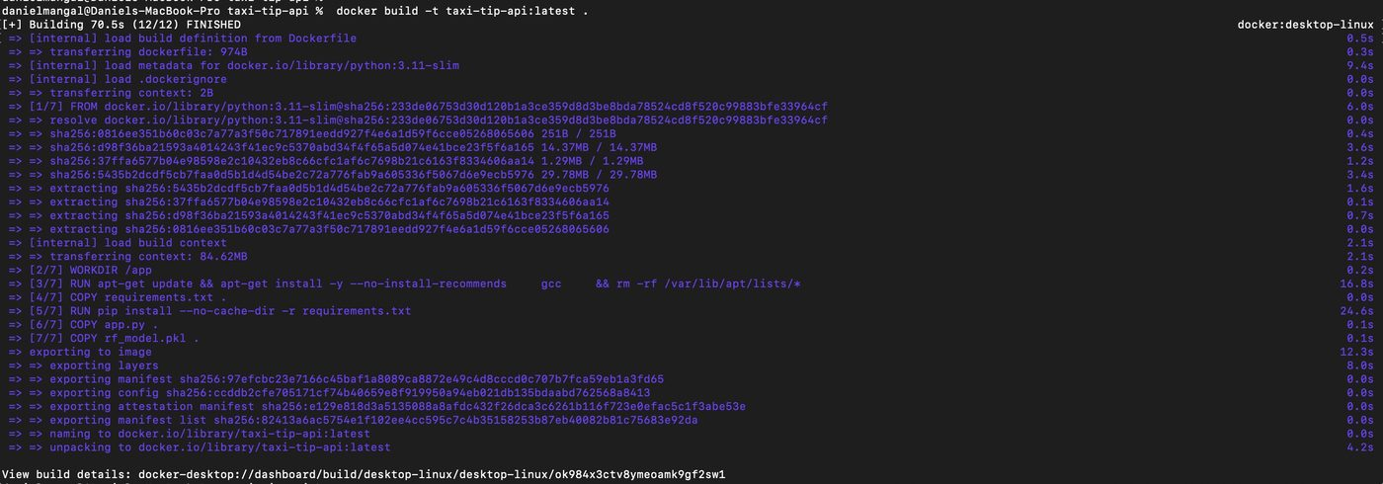
Figure 9 — docker build log: 12/12 layers finished in 70.5s; image tagged docker.io/library/taxi-tip-api:latest.

